GENESIS COMMENTARY
LIBERIA’S UNFINISHED HEALING
From War Trauma, Anger and Self-Medication to
National Recovery, Reintegration and Peace
Liberia ended its armed conflict more than two decades ago. But peace agreements can silence weapons without healing the people who carried, witnessed and survived the war.
By Fredrick Samuel Gibson, Sr., MSc, MA, MPA, MBA
Policy Analyst • Criminologist • Counselor and Rehabilitation Practitioner • Homeland Security Professional
President & CEO, Genesis Global Initiatives
www.GenesisGlobalInitiatives.org | info@GenesisGlobalInitiatives.org
A NATIONAL CALL FOR TRAUMA-INFORMED RECONCILIATION

The War Ended. The Wounds Did Not.
Liberia’s civil conflict formally ended in 2003, but for many Liberians the war remains psychologically present. It survives in memories of massacres, forced recruitment, displacement, sexual violence, execution, hunger, betrayal and the sudden disappearance of family members. It can also survive in chronic mistrust, explosive anger, substance dependence, domestic conflict, social isolation, political intolerance and a belief that force is the only language capable of producing change.
This does not mean that every survivor is mentally ill, that every angry person is dangerous, or that every former combatant uses drugs. Such generalizations would be false and stigmatizing. Most survivors have demonstrated extraordinary resilience. But resilience must never be used as an excuse for institutional neglect. A society can function while remaining deeply wounded, and those wounds can travel across families and generations when they are neither acknowledged nor treated.
In my work as a counselor, rehabilitation practitioner and criminologist—including work with people affected by violence, addiction, criminal justice involvement and community trauma—I have repeatedly seen how untreated pain can be expressed as aggression, withdrawal, hypervigilance, hopelessness or self-medication. Alcohol and drugs may temporarily numb intrusive memories, shame, grief or sleeplessness, but they can also deepen illness, poverty, family instability and conflict with the law.

The human legacy of armed conflict: collective mobilization may end when weapons are silenced, but psychological and social recovery requires sustained national work. Photograph supplied for this publication; original source and usage rights should be confirmed before public distribution.

A Nation Must Distinguish Explanation from Excuse
Trauma may help explain destructive conduct; it does not excuse violence, criminality or threats against constitutional government. Liberia must be capable of holding two truths at once: people remain responsible for their choices, and prevention requires understanding the conditions that shape those choices.
When a survivor expresses rage, glorifies military rule or presents violence as the only answer, society should neither romanticize the rhetoric nor immediately reduce the person to an enemy. The responsible response is to set a firm boundary against violence, assess observable behavior, open a path to support, and redirect legitimate grievance toward lawful civic participation. Prevention is strongest when dignity and accountability operate together.

The Postwar Work Liberia Began—but Did Not Complete
It would be historically inaccurate to say that Liberia undertook no reconciliation effort. The Truth and Reconciliation Commission operated from 2006 to 2009, collected testimony in all fifteen counties and within the diaspora, examined root causes and abuses, and issued recommendations concerning justice, reparations, institutional reform and reconciliation. County consultations and a National Reconciliation Conference were held. The Palava Hut mechanism was later piloted, including community-level dialogue supported by the Independent National Commission on Human Rights, UNDP and OHCHR.
The central failure was therefore not the complete absence of ideas. It was the lack of sustained, adequately funded and nationally coordinated implementation. Testimony without long-term care can reopen wounds. Recommendations without execution can deepen cynicism. Short projects cannot substitute for a generation-long national healing policy. Reconciliation cannot be reduced to ceremonies, political speeches or the expectation that survivors should simply forget.

The Continuing Challenges

1. Unprocessed grief and traumatic memory
Many survivors never received an opportunity to mourn safely, learn what happened to missing relatives, or tell their stories in a confidential and culturally respectful setting. Trauma may be carried silently until a political dispute, family conflict, anniversary, public figure or social-media argument activates the original wound.

2. Former combatants without durable civilian pathways
Disarmament and demobilization are events; reintegration is a long-term social and economic process. Former combatants who lack education, marketable skills, stable housing, employment and community acceptance remain vulnerable to exploitation, substance use, criminal networks and political mobilization. Reintegration must include livelihoods and belonging—not merely the surrender of a weapon.
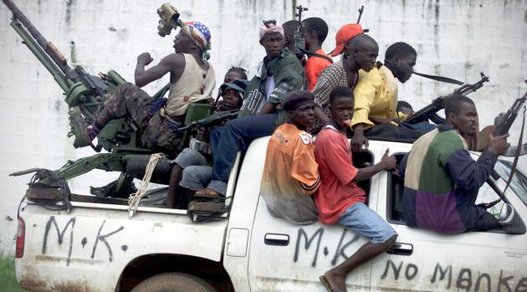
Disarmament is only the beginning. Durable reintegration requires education, livelihoods, treatment, accountability and community acceptance. Photograph supplied for this publication; original source and usage rights should be confirmed before public distribution.

3. Self-medication and the expanding drug crisis
Some Liberians exposed to war-related violence use alcohol or drugs to suppress memories, anxiety, shame, physical pain or insomnia. Others entered substance use through peer networks, homelessness, unemployment or contemporary trafficking markets. The national response must therefore avoid a single explanation. Liberia needs integrated assessment and treatment for trauma, substance-use disorders and social instability rather than punishment alone.

4. Intergenerational transmission
Children born after the war may still inherit its consequences through parental grief, disrupted attachment, family secrecy, poverty, harsh discipline, community mistrust and stories of unresolved revenge. They did not witness the battlefield, but they may grow up inside its emotional aftermath.

The recruitment and exposure of children to armed conflict represent one of war’s most enduring injuries. Children require specialized protection, education, family support and trauma-informed reintegration. Photograph supplied for this publication; original source and usage rights should be confirmed before public distribution.

5. Stigma and inadequate access to care
Mental distress is too often interpreted as weakness, spiritual failure or madness. Professional services remain limited, especially outside Monrovia. Any credible national strategy must integrate evidence-based care with trusted community structures while safeguarding informed consent, confidentiality and human rights.

6. Political grievance and the normalization of force
When citizens repeatedly experience corruption, exclusion, unemployment and weak institutions, old narratives of violent rescue may return. Military seizure of power can be falsely portrayed as discipline or national salvation. Liberia’s history teaches the opposite: unconstitutional violence weakens institutions, creates new victims and transfers power to those most willing to use force. The answer to democratic disappointment is democratic repair—not another gun.

PEACEBUILDING REQUIRES LEGITIMATE, PROFESSIONAL INSTITUTIONS. A disciplined and trusted police service should protect constitutional order, prevent violence, build community confidence and help preserve the peace for which Liberians paid so dearly. Photograph supplied for this publication; original source and usage rights should be confirmed before public distribution.

The Genesis National Healing and Prevention Framework
Genesis Global Initiatives proposes that Liberia treat national healing as a development, health, justice and security priority. The response should be nonpartisan, survivor-centered, county-based and connected to measurable economic opportunity. It should not diagnose an entire nation or criminalize political frustration. Its purpose should be to reduce suffering, interrupt pathways to violence and restore people to meaningful civic and economic life.

Experience Behind the Genesis Proposal
This framework is not based on theory alone. My professional development has included participation in conventions and training on the impact of crime upon families and society, transnational crime, and the street-level distribution of narcotics. Those experiences reinforced the inseparable relationship among public safety, drug policy, treatment, family stability and community recovery.
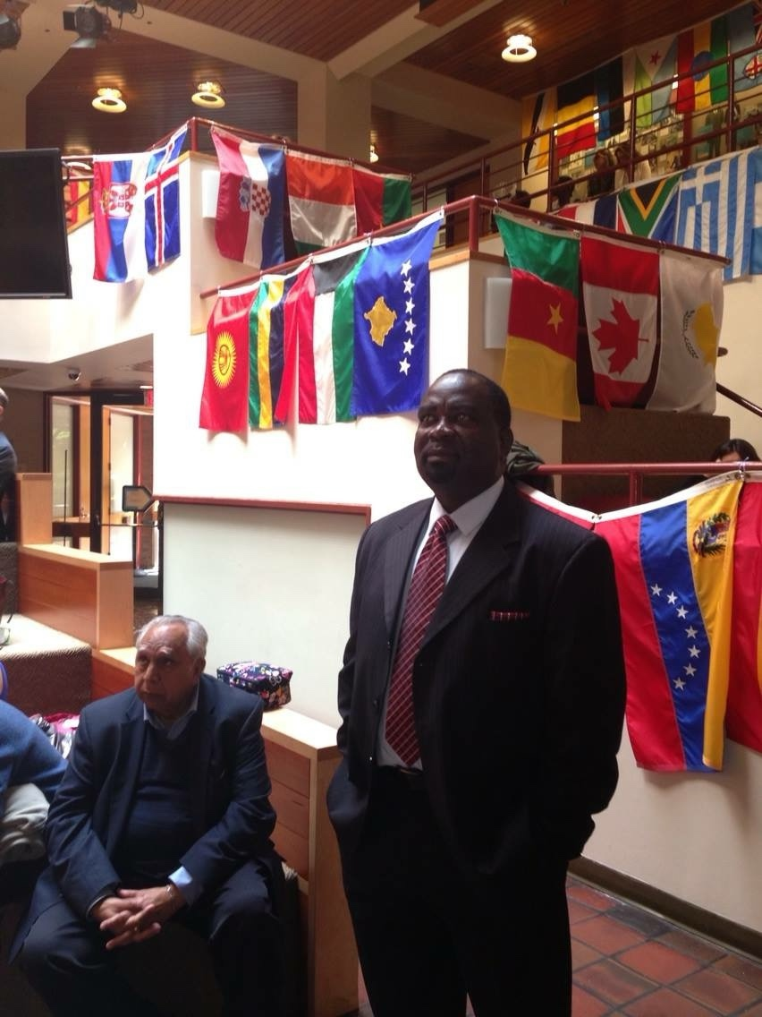
PROFESSIONAL PREPARATION FOR A GLOBAL CHALLENGE. Fredrick Samuel Gibson, Sr. attending a convention and training program examining crime’s impact on families and society, transnational criminal activity, and street-level narcotics distribution.

Pillar One: A National Trauma, Mental Health and Substance-Use Assessment
- Conduct an ethically designed national needs assessment covering all fifteen counties and major diaspora communities.
- Map available counselors, social workers, nurses, peer-recovery specialists, faith-based supports, treatment facilities and referral gaps.
- Disaggregate findings by age, gender, disability, county, wartime experience, displacement, former combatant status and substance-use needs—while protecting identity and confidentiality.
- Develop a national referral directory and crisis-response protocol that communities can actually use.

Pillar Two: County Healing and Recovery Centers
Each county should have an accessible center or coordinated network offering trauma screening, individual and group counseling, substance-use treatment, family support, psychiatric referral, peer recovery, legal and social-service navigation, and vocational case management. Mobile teams should reach rural districts, schools, prisons, market communities and areas with high concentrations of vulnerable youth.
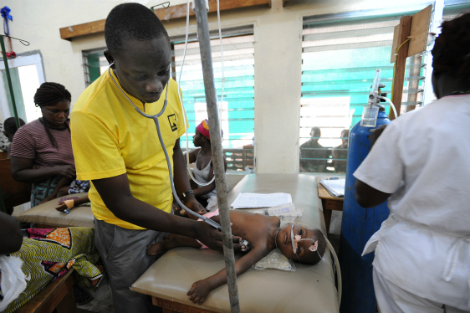
Recovery must reach the health system: county-based services should connect physical care, trauma treatment, substance-use recovery and family support. Photograph supplied for this publication; original source and usage rights should be confirmed before public distribution.
The administrative and clinical demands of treatment also require accountable leadership. As a clinical supervisor and program manager at a methadone clinic, I worked from the point where treatment plans, staffing, documentation, client progress and program standards had to be translated into daily practice. Liberia’s recovery system will likewise require trained supervisors, reliable records, ethical safeguards and measurable outcomes.
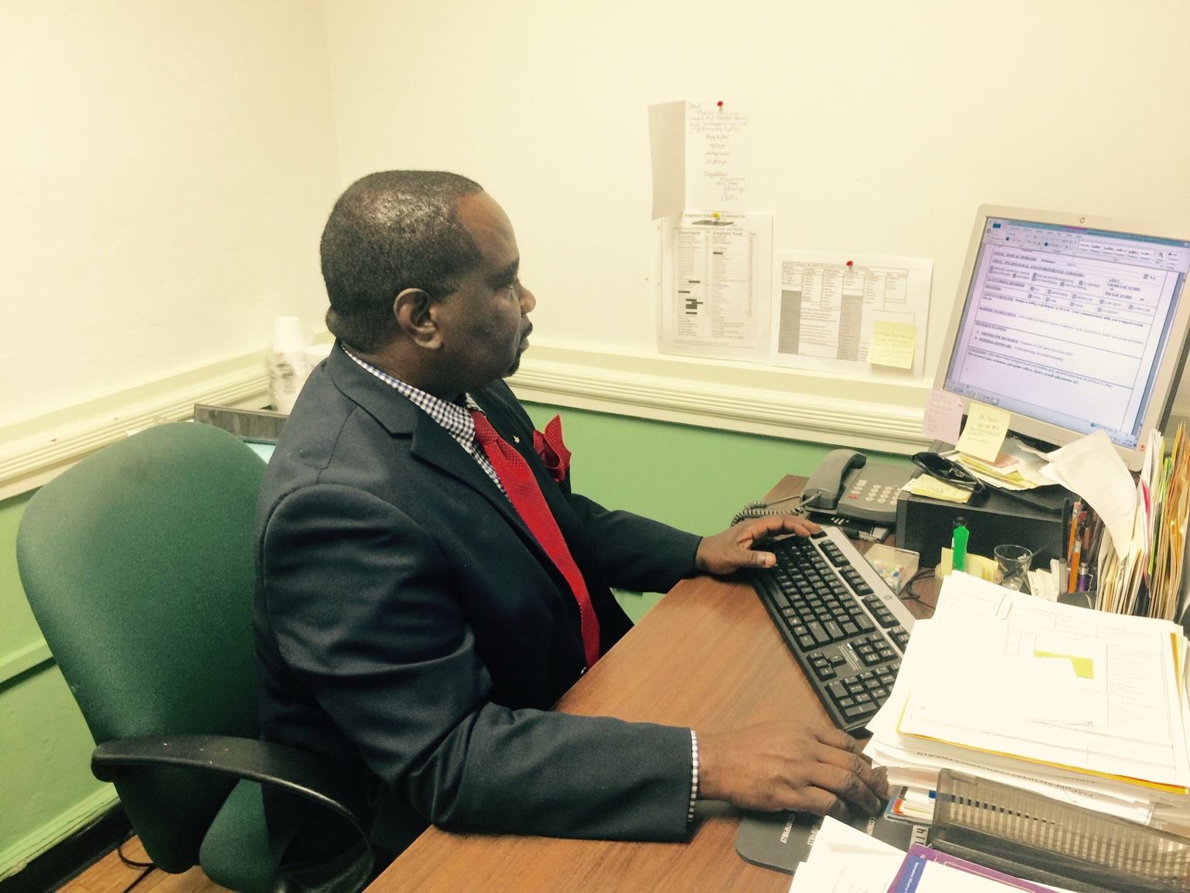
CLINICAL LEADERSHIP IN PRACTICE. Fredrick Samuel Gibson, Sr. working in his office while serving as a clinical supervisor and program manager at a methadone treatment clinic—the same program in which structured advancement ceremonies were introduced to recognize client progress.

Pillar Three: Community Healing Circles with Clinical Safeguards
Liberia should build upon culturally recognized dialogue mechanisms, including Palava Hut traditions, without treating communal dialogue as a replacement for professional care or formal justice. Participation must be voluntary. Facilitators must be trained in trauma, confidentiality, gender-based violence, suicide awareness, conflict de-escalation and safe referral. Survivors must never be pressured to forgive, confront an alleged perpetrator or disclose experiences publicly.

Pillar Four: Reintegration Through Education, Work and Ownership
Healing without livelihood is fragile. A renewed reintegration compact should connect former combatants, war-affected families, recovering drug users and vulnerable youth to literacy, apprenticeships, agriculture, construction, transportation, environmental restoration, cooperatives and small-business financing. Benefits should be needs-based and community-inclusive so assistance does not appear to reward violence while neglecting victims and peaceful citizens.
Recovery also becomes stronger when people can see and celebrate forward movement. In a treatment program I managed during the formative period of the Genesis vision, I introduced graduation ceremonies recognizing clients who completed the intensive outpatient phase and advanced to outpatient care. The milestone gave participants a concrete goal and allowed family members to witness progress with dignity.
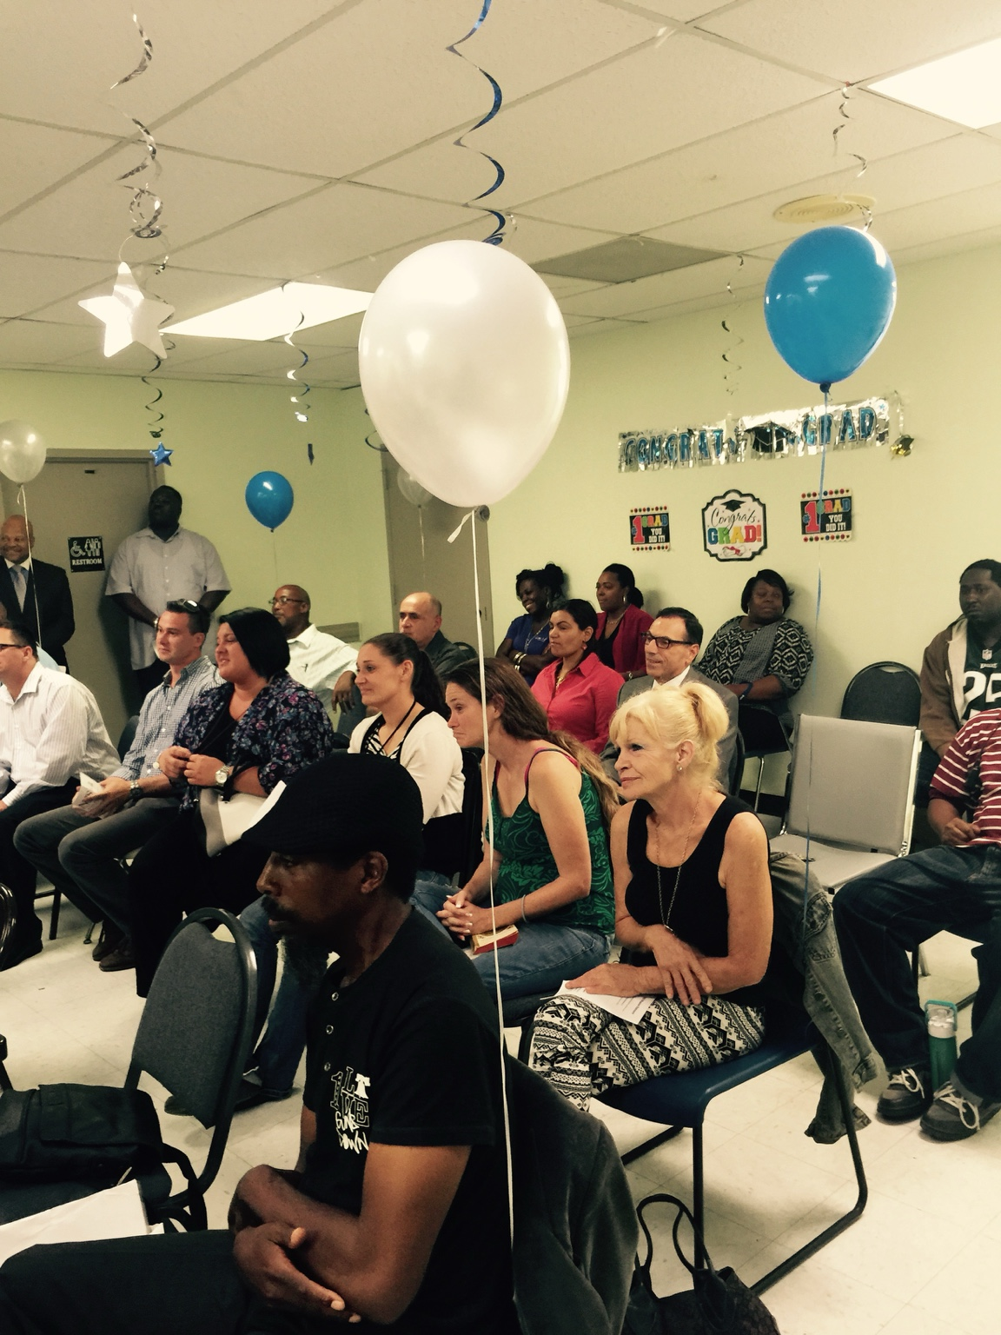
FAMILIES AS PARTNERS IN RECOVERY. Relatives, treatment participants and staff gather for a structured advancement ceremony recognizing movement from intensive outpatient treatment to the next phase of care. The presence of family restored dignity, strengthened accountability and made recovery visible.

Pillar Five: Family and School-Based Prevention
Teachers, parents, religious leaders and community health workers should receive practical training to recognize distress, bullying, substance use, domestic violence, withdrawal, escalating grievance and threats. Schools should teach emotional regulation, conflict resolution, civic responsibility and the history of the civil conflict in an age-appropriate, evidence-based manner that avoids ethnic blame or political propaganda.

Education is a prevention strategy. Safe schools can strengthen resilience, civic responsibility, opportunity and peaceful conflict resolution among the postwar generation. Photograph supplied for this publication; original source and usage rights should be confirmed before public distribution.
Professional education must extend beyond traditional classrooms. During the period of widespread opioid overdose deaths, I led a breakout training session addressing the devastating effects of opioid use. Liberia’s prevention strategy should similarly equip frontline workers, families, educators and community leaders with practical knowledge about overdose, trauma, treatment and referral.
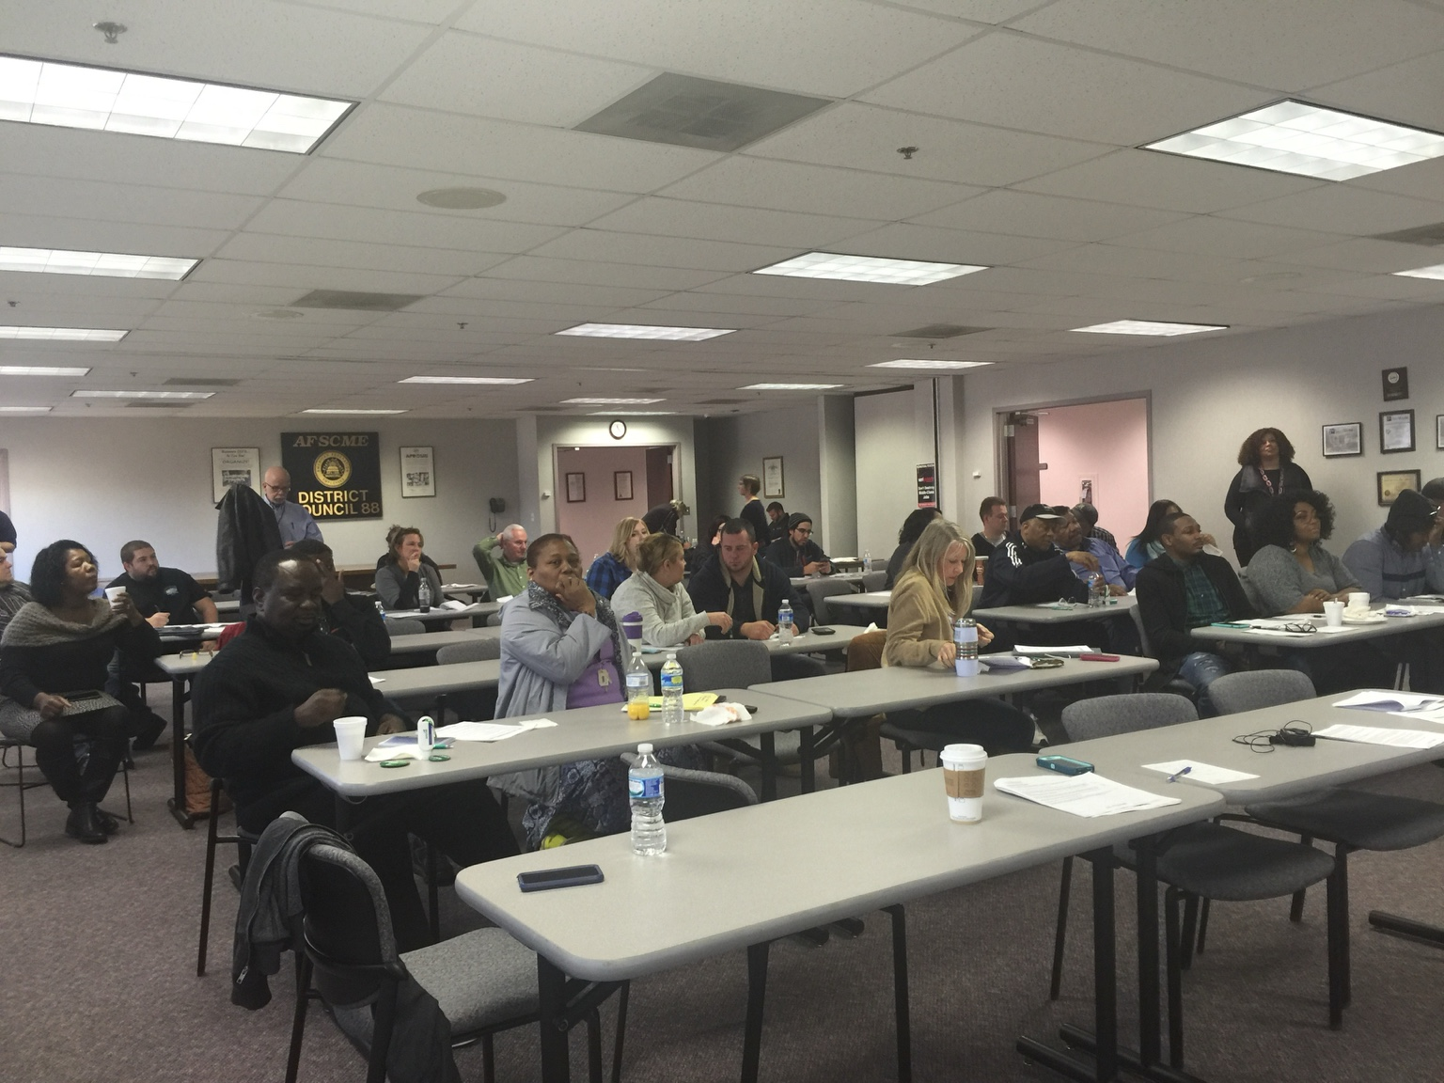
OPIOID EDUCATION AS PREVENTION. A breakout session led by Fredrick Samuel Gibson, Sr. on the devastating impact of opioid use during a period of widespread overdose deaths. Training helps communities recognize risk, respond earlier and connect people with treatment.

Pillar Six: A Responsible Response to Threatening Rhetoric
Families and friends need a clear public guide. They should listen without validating violence; ask directly whether a statement represents frustration or an actual plan; preserve concerning communications; avoid promising secrecy; and seek professional or law-enforcement assistance when a person identifies targets, methods, preparation, recruitment or timing. Not every angry statement predicts violence, but specific movement toward planning requires escalation to trained authorities.

Pillar Seven: Truth, Reparations and Institutional Follow-Through
Psychosocial healing cannot substitute for justice, and justice cannot by itself provide treatment. Liberia needs transparent public accounting of which Truth and Reconciliation Commission recommendations have been implemented, which remain outstanding, what legal and constitutional questions remain, and how victims will participate in decisions concerning reparations, memorialization, accountability and reconciliation.

A Proposed Genesis First-Phase Intervention
Genesis Global Initiatives should begin with a carefully bounded pilot rather than an oversized promise. A twelve-month first phase could combine public education, stakeholder consultation and direct referral capacity:
- Publish a national commentary and radio/podcast series on trauma, recovery, nonviolence and democratic participation.
- Convene a multidisciplinary advisory group of Liberian mental-health professionals, survivors, youth representatives, women’s organizations, traditional leaders, recovery specialists, criminologists, educators, human-rights advocates and diaspora practitioners.
- Hold confidential listening sessions in selected counties and diaspora communities, followed by a public National Healing Policy Forum.
- Train an initial cohort of community gatekeepers in psychological first aid, de-escalation, substance-use referral and safeguarding.
- Launch a pilot referral and recovery-navigation service with documented consent, privacy procedures and professional supervision.
- Produce a costed Genesis National Healing and Reintegration Blueprint for government, donors, universities, civil society and development partners.
A recovery-centered intervention must also create milestones people can believe in. Recognition is not a substitute for clinical standards; it is a motivational tool that can help participants and families see that treatment is a process of achievable stages.
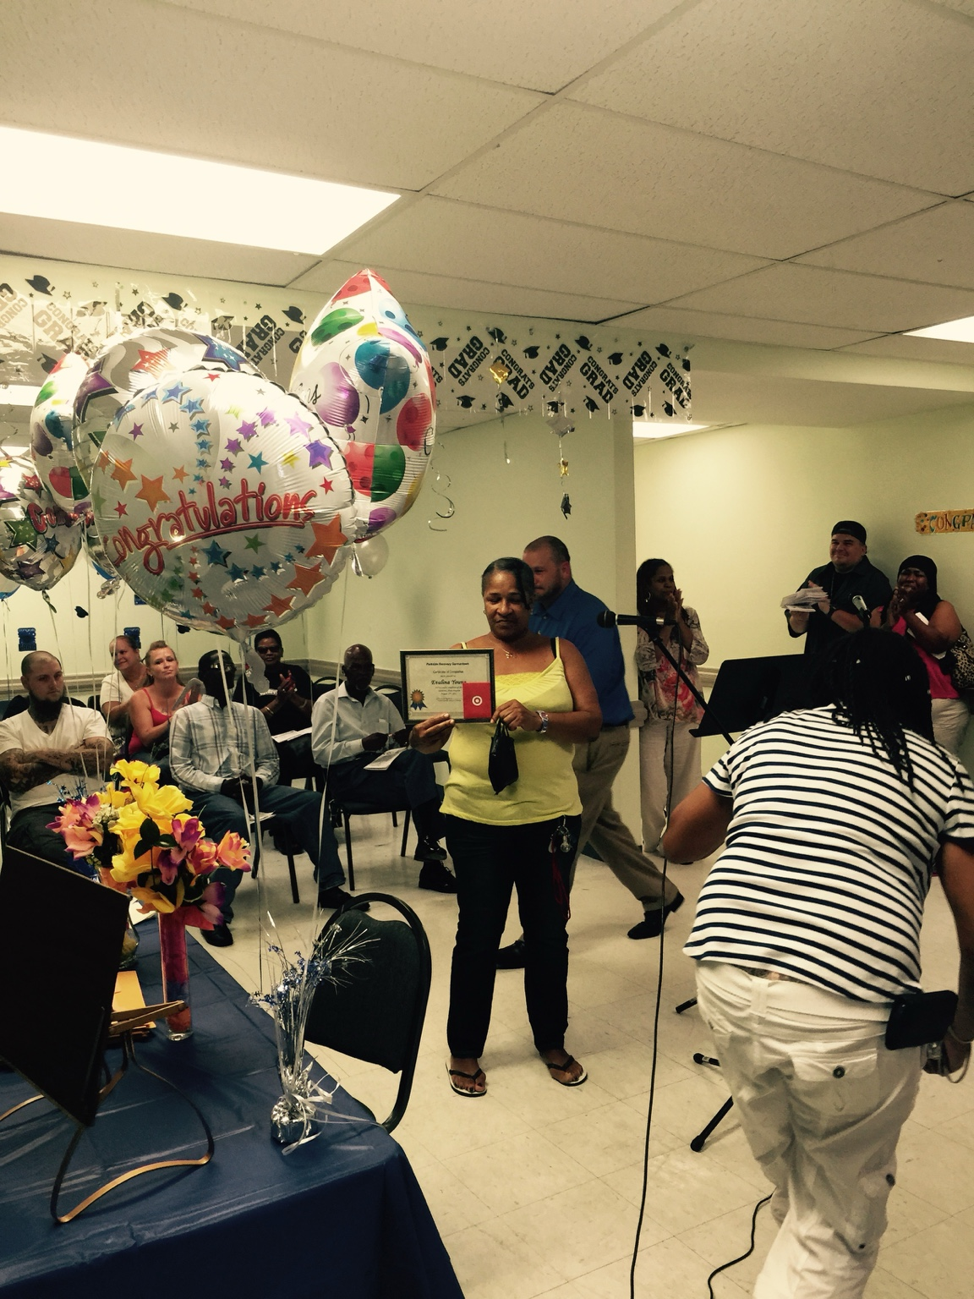
RECOVERY WORKS. A treatment participant displays her certificate after completing the intensive outpatient phase and advancing to outpatient care. The ceremony—an initiative introduced under the author’s program leadership—affirmed progress before family members, peers and staff and helped participants prove to themselves that sustained recovery was possible.

From Commentary to National Action: December 24, 2026
Genesis Global Initiatives proposes a peaceful One Million People’s March for Healing, Recovery and National Renewal on December 24, 2026. The proposed mobilization would bring together survivors, families, young people, recovery communities, traditional and religious leaders, civil society, professional associations, county organizations, diaspora communities and leaders of every political party around a cause that belongs to no single party: protecting Liberia from drugs, organized crime, untreated trauma and renewed violence.
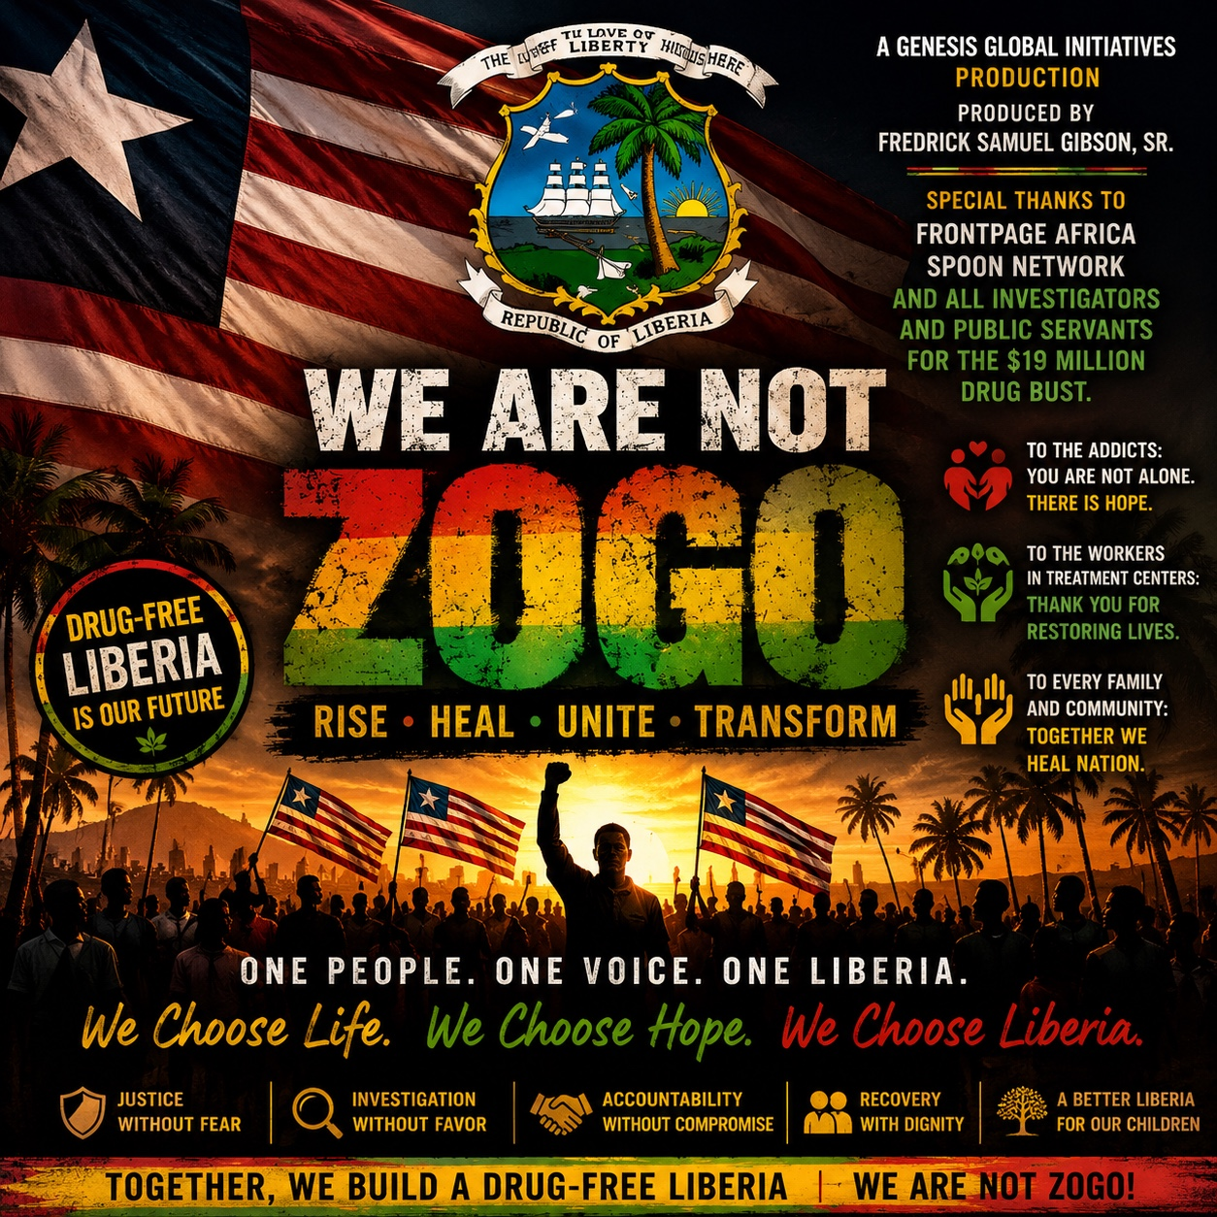
PUBLIC-AWARENESS ARTWORK FOR A DRUG-FREE LIBERIA. The Genesis “We Are Not Zogo” campaign calls Liberians to rise, heal, unite and transform while affirming justice, accountability, treatment, family support and recovery with dignity. Campaign artwork supplied by Genesis Global Initiatives.

Why December 24 Matters
December 24 is not being chosen as a celebration of war. It is being reclaimed from war. United Nations historical records identify December 24, 1989, as the day Charles Taylor led National Patriotic Front of Liberia fighters into the country, initiating the conflict that devastated Liberia. Genesis proposes transforming that painful anniversary into an annual Day of Healing, Recovery and National Renewal—a day on which Liberians remember the consequences of violence, recommit themselves to constitutional peace, support people in recovery and refuse to allow another generation to be destroyed.
Liberia has held elections, restored constitutional civilian government and sustained formal peace, but it has not yet institutionalized a broadly observed annual day centered upon postwar healing, trauma recovery, reconciliation and nonviolence. The proposed observance should therefore complement—not replace—the Truth and Reconciliation Commission record, existing memorial practices, justice processes or the individual ways in which families remember their dead.

Why the Drug Crisis Makes the Mobilization Urgent
The proposal comes amid an alarming succession of narcotics cases. In June 2026, authorities intercepted approximately 237.6 kilograms of cocaine, valued at about US$19 million, at Roberts International Airport. In July, authorities reported the seizure of nearly four metric tonnes of cocaine valued at approximately US$317 million near Monrovia. Subsequent investigations produced arrests and charges involving Liberian and foreign nationals, including prominent public figures and security personnel. Charges are allegations, and every accused person remains entitled to due process and the presumption of innocence. Nevertheless, the scale of the seizures demonstrates that Liberia faces both a domestic public-health emergency and exposure to sophisticated transnational trafficking networks.
The march should therefore oppose two connected dangers: the international trafficking systems that seek to use Liberia as a transit and storage corridor, and the expanding local drug market that destroys young people, burdens families and encourages crime. Public outrage must be converted into prevention, treatment, professional investigation, accountable prosecution and sustained recovery support.

Proposed National Healing and Recovery Week | December 18–24, 2026
- December 18 — Opening and National Remembrance Forum: survivor voices, historical reflection, interfaith prayer and a public commitment to nonviolence.
- December 19 — Criminal Justice and Transnational Crime Forum: trafficking routes, border and port security, policing integrity, financial investigation, prosecution, judicial independence and regional cooperation.
- December 20 — National Drug Policy Forum: prevention, supply reduction, legislation, evidence, institutional coordination and protection against political interference.
- December 21 — Treatment and Recovery Forum: trauma-informed care, detoxification, medication-assisted treatment, residential and outpatient services, peer recovery, relapse prevention and family participation.
- December 22 — Youth, Education and Family Forum: school prevention, skills development, employment, sports, arts, parenting support and protection of children from recruitment into drug markets.
- December 23 — Community Reconciliation and Service Day: county dialogues, Palava Hut-informed healing activities, memorial observances, community feeding and support for vulnerable families.
- December 24 — One Million People’s March for Healing, Recovery and National Renewal: peaceful county and diaspora mobilizations culminating in a national declaration against drugs, violence and unconstitutional change.

One Million as a National Mobilization Goal
The phrase “One Million People” should be understood as an inclusive national mobilization goal rather than an unverified prediction of attendance at a single location. Participation could be counted across Monrovia, the fifteen counties and diaspora communities through registered marches, community events, schools, houses of worship, recovery organizations and verified online engagement. Transparent registration and post-event reporting would protect the credibility of the initiative.
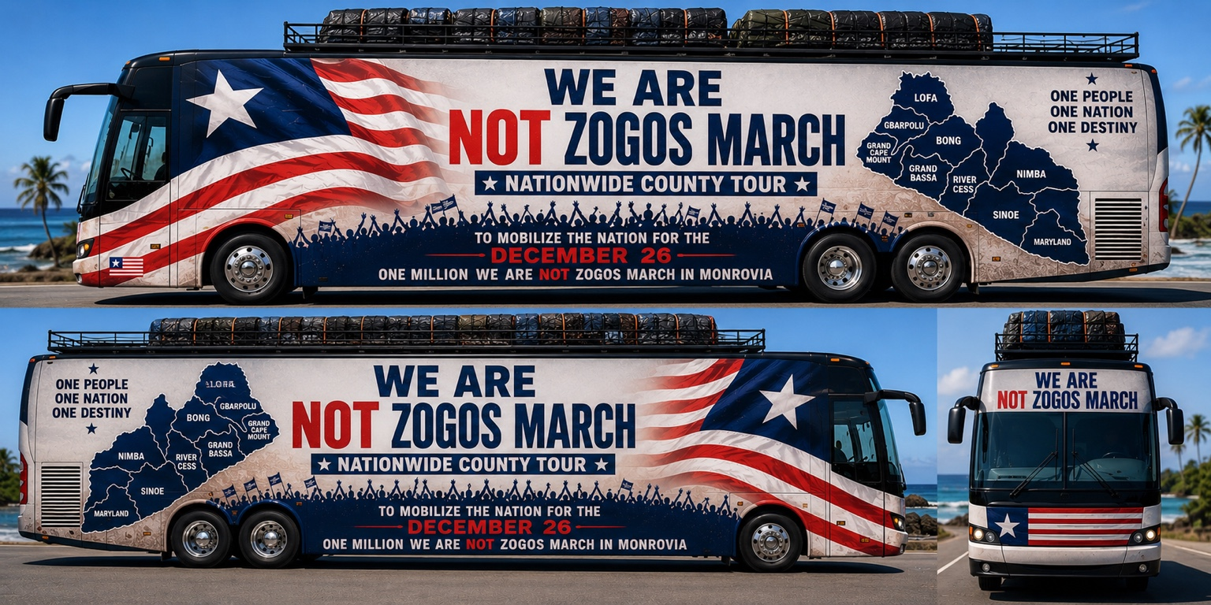
CONCEPT FOR A NATIONWIDE COUNTY AWARENESS TOUR. The proposed mobile campaign would carry the message of dignity, treatment and national mobilization beyond Monrovia. IMPORTANT: this conceptual artwork displays December 26; it must be revised to December 24, 2026, before any official public or printed use.

A Peaceful, Nonpartisan and Properly Safeguarded Event
The proposed march must be organized in consultation with the appropriate government, municipal, health and security authorities. It should require lawful permits, agreed routes, trained marshals, emergency medical support, traffic and crowd planning, accessibility arrangements, child-safeguarding procedures and a written code of nonviolence. Political parties and their leaders should be welcomed as equal national stakeholders, but no party should be permitted to capture the event, campaign from its platform or exclude another organization.

Genesis Feeding: Service Before the March
Genesis Feeding has already commenced a feeding effort in Monrovia as a practical prelude to the proposed December mobilization, with the longer-term objective of reaching vulnerable communities throughout Liberia. Genesis welcomes support in cash or in kind to sustain and expand the program. All appeals should be made through officially authorized channels with receipts, inventory controls, safeguarding procedures and periodic public accounting so that every contribution can be traced to its humanitarian purpose.
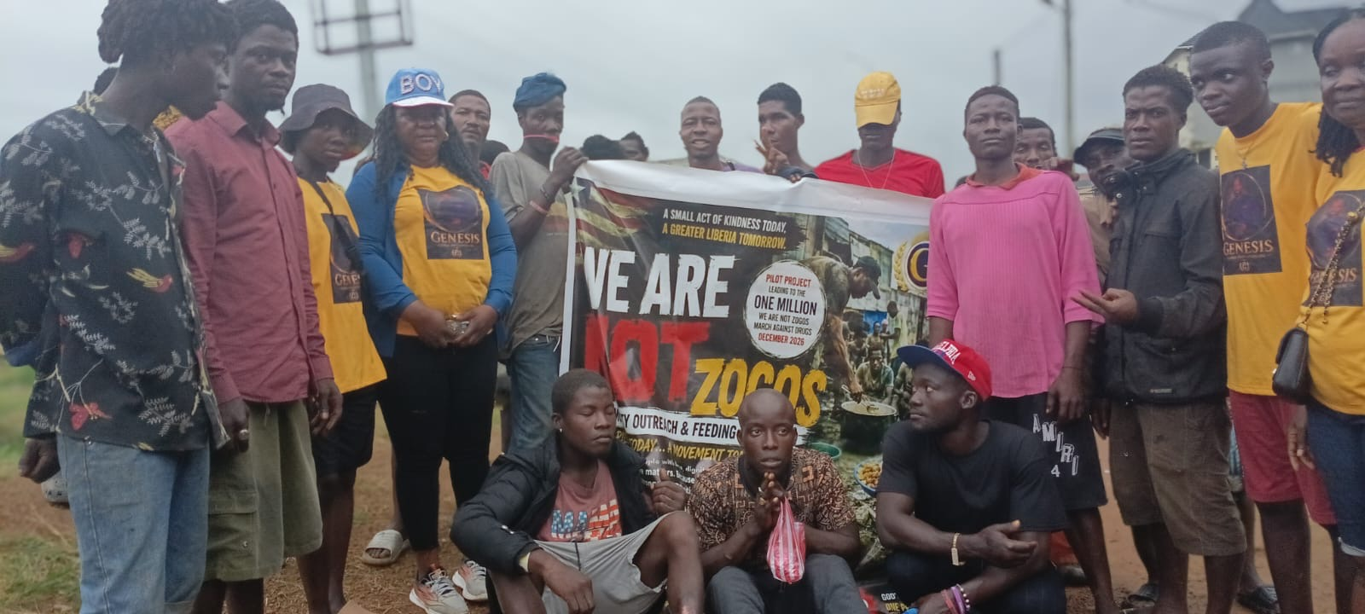
SERVICE BEFORE MOBILIZATION. Genesis volunteers and community members gather during the continuing Monrovia feeding and outreach program. The effort combines immediate humanitarian service with public awareness leading toward the proposed December 24, 2026, national mobilization. Photograph supplied by Genesis Global Initiatives.
The feeding effort is also a method of respectful engagement. It creates an opportunity to meet vulnerable people where they are, listen to their experiences, share information about recovery and reinforce the message that no Liberian should be reduced to a stigmatizing label. With adequate support, Genesis intends to continue the Monrovia outreach and expand responsibly into rural counties.
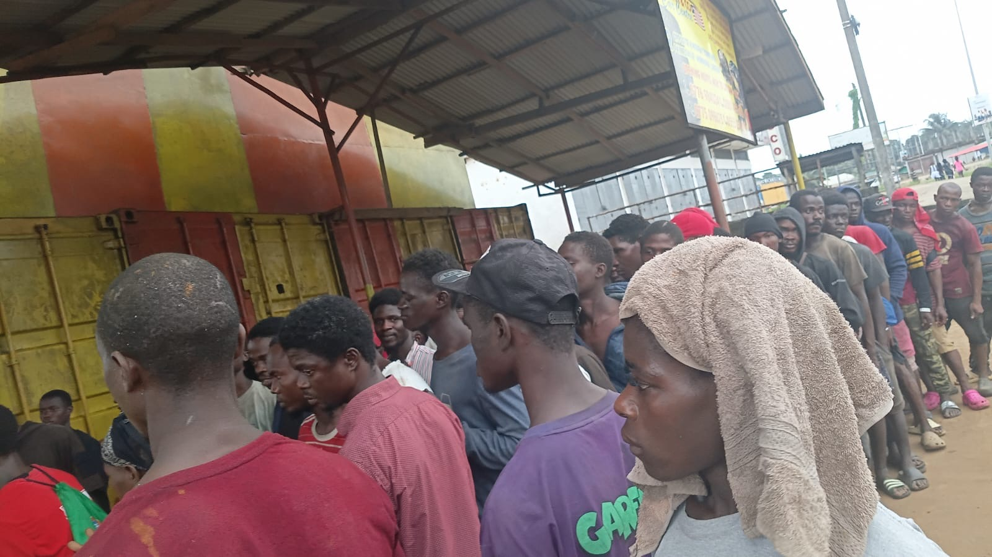
DIGNITY IN ACTION. Community members line up during a recent Genesis feeding outreach in Monrovia. With additional cash and in-kind support, the initiative seeks to sustain service in the capital and expand into rural counties while building awareness for December 24, 2026. Photograph supplied by Genesis Global Initiatives.
LEARN MORE OR SUPPORT THE OUTREACH
www.GenesisGlobalInitiatives.org | info@GenesisGlobalInitiatives.org
Liberia: Aryee Davis, Country Director | +231 77 791 3295
DECEMBER 24: RECLAIMING A DAY OF INVASION AS A DAY OF HEALING — AND TURNING NATIONAL ANGER ABOUT DRUGS INTO PREVENTION, TREATMENT, ACCOUNTABILITY AND RECOVERY.

Principles That Must Govern the Work
- Do no harm: avoid sensationalism, forced disclosure and public labeling.
- No collective diagnosis: war exposure does not make all survivors violent or mentally ill.
- Survivor leadership: programs must be designed with—not merely for—affected people.
- Nonpartisanship: healing services must never be conditioned on party membership or political loyalty.
- Dignity with accountability: recognize trauma while maintaining clear boundaries against violence and abuse.
- County equity: services cannot remain concentrated in Monrovia.
- Evidence and measurement: track access, retention, recovery, employment, family stability, relapse, safety and participant satisfaction.

The Peace Liberia Must Now Build
Liberia has maintained formal peace for more than two decades. That achievement deserves protection. But negative peace—the absence of open warfare—is not the same as healing, justice or human security. A nation is not fully reconciled while survivors suffer silently, former combatants remain economically abandoned, young people inherit unresolved grievance, and drugs become anesthesia for pain that society refuses to name.
We must reject two dangerous extremes: pretending that the past no longer matters, and allowing the past to justify new violence. Liberia’s future will not be built through revenge, military seizure or the barrel of a gun. It must be built through treatment, truth, accountability, opportunity, institutional reform and the ballot box.
Genesis Global Initiatives is prepared to help open this conversation, assemble partners and develop a practical framework for national intervention. The purpose is not to reopen wounds recklessly. It is to stop untreated wounds from reopening Liberia.
The war ended in 2003. The responsibility to heal did not.

About Genesis Global Initiatives
Genesis Global Initiatives is a nonpolitical, nonprofit-oriented development and policy framework committed to youth empowerment, education, public health, restorative justice, rehabilitation and recovery, informal-sector modernization, employment creation and inclusive national development. Through research, publications, community engagement and partnership-building, Genesis seeks practical responses to the interconnected challenges affecting Liberia and comparable communities.

Liberia Headquarters and Local Contact
ARYEE DAVIS
Country Director, Genesis Global Initiatives — Liberia
Telephone: +231 77 791 3295
HEADQUARTERS & LOCAL OFFICES
Duport Road — Zubah Town
Paynesville, Liberia
West Africa

About the Author
Fredrick Samuel Gibson, Sr. is a Liberian-American policy analyst, criminologist, counselor and rehabilitation practitioner, homeland security professional, author, and President & CEO of Genesis Global Initiatives. His professional experience includes counseling and program leadership involving addiction, rehabilitation, community corrections, returning citizens and people affected by trauma. His academic training spans criminal justice and criminology, administration of justice, public administration, management and leadership, homeland security, and environmental sustainability and corporate social responsibility.

Selected Sources and Further Reading
- Truth and Reconciliation Commission of Liberia. Final Report, Volumes I–III (2009), including appendices on psychosocial needs and Palava Hut/peace forums. https://www.trcofliberia.org/reports/final-report.html
- World Health Organization. Culture and Mental Health in Liberia: A Primer (2017). https://iris.who.int/handle/10665/255302
- United Nations Development Programme and Office of the High Commissioner for Human Rights. Support to Liberia’s Palava Hut transitional-justice process, reported in UNDP Annual Report 2016. https://www.undp.org/publications/undp-annual-report-2016
- United Nations Peacebuilding Fund. TRC Final Reconciliation Initiatives: County Consultations and National Reconciliation Conference (2009). https://mptf.undp.org/document/trc-final-reconciliation-initiatives
- UNEP and UNDP. The Role of Natural Resources in Disarmament, Demobilization and Reintegration (2013), emphasizing reintegration as a long-term social and economic process. https://www.undp.org/publications/role-natural-resources-disarmament-demobilization-and-reintegration
- World Health Assembly. Resolution on strengthening mental health and psychosocial support before, during and after armed conflicts and emergencies (2024). https://apps.who.int/gb/ebwha/pdf_files/EB156/A77_REC1_EXTRACT-en.pdf
- Federal Bureau of Investigation, Behavioral Analysis Unit. Making Prevention a Reality: Identifying, Assessing, and Managing the Threat of Targeted Attacks. https://www.fbi.gov/file-repository/making-prevention-a-reality.pdf
- United Nations / Government of Liberia. Core Document Forming Part of the Reports of States Parties: Liberia (HRI/CORE/LBR/2016), recording December 24, 1989, as the date Charles Taylor led NPFL fighters into Liberia. https://digitallibrary.un.org/record/844443
- Reuters. Liberia Seizes Approximately US$317 Million of Cocaine Bound for Europe (July 24, 2026), with reference to the earlier 237.6-kilogram airport seizure. https://www.reuters.com/world/americas/liberia-seizes-317-million-cocaine-bound-europe-police-chief-says-2026-07-24/
- Associated Press. Liberian Authorities Burn Cocaine Following Record Seizure; Senior Police Officials Implicated (July 30, 2026). https://apnews.com/article/3682e64dcef53f0a7961371e028e19e4

Publication Note
This commentary is intended for public education, policy discussion and prevention. It does not diagnose any individual or population and is not a substitute for medical, psychological, legal or emergency services. Where there is a specific or imminent threat of violence, contact the appropriate authorities and emergency services.

