GENESIS GLOBAL INITIATIVES, INC.
WEEKLY POLICY & PUBLIC SAFETY REVIEW
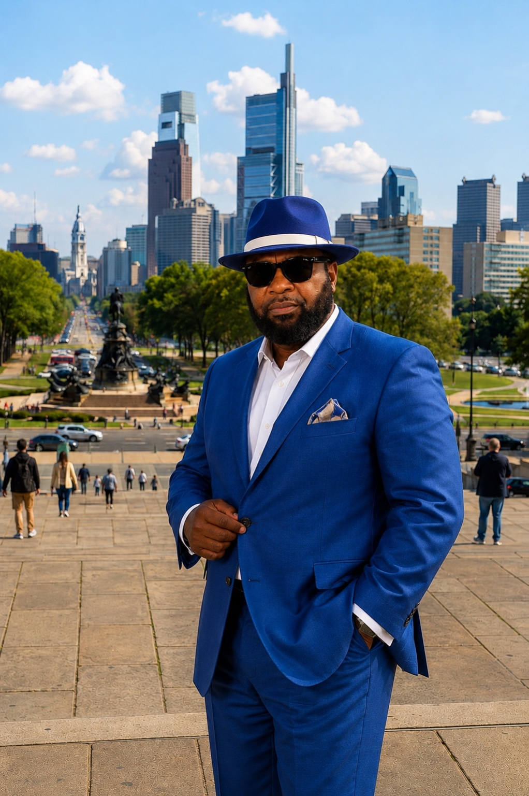
FREDRICK SAMUEL GIBSON, SR., MSc, MA, MPA, MBA
Criminologist | Criminal Justice Professional | Homeland Security Practitioner
Transnational Crime & Drug-Trafficking Research Analyst
LIBERIA’S WAR AGAINST DRUG TRAFFICKING
When Activism, Evidence, Ethics, and National Security Collide
A Criminological and National-Security Analysis of Martin K. N. Kollie’s “Octopus Operation”
SERIES  Genesis Weekly Publications | EDITION  August 21, 2026 | READING TIME  Approximately 14–15 minutes

EDITORIAL POSITION
This analysis neither adopts nor dismisses the allegations in Mr. Kollie’s publication. It evaluates their criminological, ethical, legal, philosophical, and national-security significance while preserving the presumption of innocence and demanding evidence-based accountability.

Introduction: A Serious Publication at a Dangerous National Moment
I have carefully reviewed the recent publication by Liberian activist Martin K. N. Kollie concerning what he calls an “Octopus Operation” against an alleged drug cartel and its suspected accomplices in Liberia.
I approach this publication neither as a partisan defender of the government nor as an automatic supporter of every accusation made by an activist. I approach it from the perspective of a criminologist, criminal justice professional, homeland security practitioner, rehabilitation and recovery specialist, and researcher of transnational drug trafficking and organized criminal networks.
My professional judgment is that Kollie’s publication raises matters that Liberia cannot responsibly dismiss. It speaks to possible conflicts of interest, inconsistencies in public explanations, institutional credibility, investigatory impartiality, police procurement, alleged relationships between public officials and private contractors, and the possibility that criminal networks may have penetrated or compromised national institutions.
These are legitimate subjects for investigation. However, the seriousness of the subject also demands discipline. Allegations must not be converted into convictions through social media. Contradictory statements may justify additional questions, but contradictions alone do not prove participation in drug trafficking or corruption. Suspicion is the beginning of an investigation—not the conclusion of one.
Liberia is confronting a genuine transnational threat. In July 2026, authorities announced the seizure of approximately 3,971 kilograms of cocaine, estimated at about US$317 million, in Duazon. This followed the seizure of more than 237 kilograms of cocaine at Roberts International Airport in June. International reporting and regional experts have described West Africa as an increasingly important transit and storage corridor for sophisticated cocaine-trafficking networks moving drugs from South America toward Europe. Therefore, this is not an abstract political quarrel. Liberia is facing a national-security, public-health, governance, and human-development emergency.

What Kollie’s Publication Is Really Alleging
Kollie’s publication advances several distinct claims that must not be carelessly blended together.
First, he alleges that statements attributed to Wynfred Russell concerning the acquisition or facilitation of police vehicles are inconsistent. In one account, Russell reportedly praised Inspector General Gregory Coleman for making the acquisition possible and appeared to describe a direct procurement arrangement. In a subsequent explanation, Russell reportedly characterized his role as limited to making an introduction to a Minnesota police department.
Second, Kollie alleges that Russell served in some form of public-relations capacity for the police inspector general. That assertion, if disputed, requires documentary proof: a consultancy agreement, payment record, official appointment, procurement document, correspondence, or other independently authenticated evidence.
Third, Kollie alleges that Russell’s brother, Jose Quintin Russell, was brought from the United States to manage the Liberia National Police vehicle fleet while also operating or maintaining an interest in a private garage that allegedly receives police vehicle-maintenance contracts.
If that allegation is accurate, it could present a serious conflict-of-interest concern. But accuracy must be established through records—not assumption. Investigators should determine:
- Whether an appointment or employment relationship exists;
- Whether the individual owns, controls, or benefits from the named company;
- Whether that company received police contracts and how those contracts were awarded;
- Whether competitive procurement rules were followed;
- Whether the individual participated in recommending, approving, supervising, or certifying payments;
- Whether the relationship was properly disclosed; and
- Whether Liberia’s conflict-of-interest, procurement, or ethical-governance requirements were violated.
Fourth, Kollie challenges Executive Protection Service Director Sam Gaye’s public defense of Inspector General Coleman. He argues that a national-security official who may participate in an investigation should not publicly defend one of the people whose conduct is being questioned. Even if Gaye believes Coleman to be innocent, the appearance of impartiality matters. A national-security investigation must not only be fair; the public must be able to recognize it as fair.

Contradictory Statements: Evidence of Guilt or Grounds for Inquiry?
In criminal investigations, inconsistent statements are important. Investigators compare statements against documents, timestamps, financial records, electronic communications, witness testimony, travel records, and physical evidence.
But an inconsistency can have several explanations. It may result from poor wording, incomplete knowledge, an exaggerated public-relations presentation, misunderstanding, an attempt to minimize involvement, or deliberate deception.
The professional question is not simply, “Did the person change his story?” The proper questions are:
- Which statement is supported by documentary evidence?
- What was the person’s actual legal or contractual role?
- Who owned the vehicles, and from whom were they acquired?
- Were they donated, sold at auction, purchased through an intermediary, or obtained through another municipality?
- Who paid the purchase, transportation, refurbishment, insurance, and shipping expenses?
- Which Liberian agency authorized the transaction, and were public funds involved?
- Who inspected and accepted the vehicles?
- Was there any undisclosed personal benefit?
Until those questions are answered, the contradiction is an investigative lead. It is not, by itself, proof of corruption or cartel participation. This distinction is essential because an anti-drug campaign loses credibility if every ambiguity is immediately announced as conclusive evidence. Evidence must be gathered, authenticated, corroborated, and placed into a legally coherent chain.

The Conflict-of-Interest Question
Kollie’s most institutionally significant allegation may be the claim that a police fleet manager is connected to a private garage receiving police maintenance work.
Conflict of interest does not always require proof that money was stolen. It may exist whenever a public official’s private financial interests could improperly influence—or appear to influence—his official decisions.
If a fleet manager participates in deciding which vehicles require repair, selecting the repair facility, approving the work, confirming completion, or recommending payment while simultaneously benefiting from the company performing the work, the arrangement would raise severe ethical concerns.
Such an arrangement could undermine competition, inflate public costs, weaken quality control, and create opportunities for fraudulent invoicing. It would place demand, supplier selection, inspection, and payment authorization within overlapping circles of influence.
Nevertheless, the public must be shown reliable documents. Corporate registration, beneficial-ownership information, procurement records, invoices, payment vouchers, work orders, and the fleet manager’s official job description would provide a stronger foundation than allegations repeated across radio and social media.

The Ethical Duty of Investigators
Kollie’s criticism of Sam Gaye raises a broader principle: an investigator must be independent, impartial, and free from prejudgment.
There is an important difference between defending the institutional integrity of the government and defending a particular official before the investigation has been completed. A public official may properly say that the government will follow the evidence, protect due process, and hold every responsible person accountable. That is different from suggesting that a questioned official must be innocent because the President continues to have confidence in him.
Presidential confidence is a political and administrative judgment. It is not forensic evidence. It cannot replace financial records, witness interviews, communication data, procurement documents, or legally admissible proof.
If Gaye is serving on an investigative body examining matters connected to Coleman, a public defense could reasonably create an appearance of bias. The appropriate institutional responses could include recusal, reassignment, or the establishment of an independently supervised investigative mechanism. Recusal is not a declaration of guilt. It is a safeguard for the integrity of the investigation.

Due Process Must Apply to Everyone
The accused, the accuser, and the Liberian public all have rights.
Inspector General Coleman, Wynfred Russell, Jose Quintin Russell, and Sam Gaye are entitled to the presumption of innocence and a meaningful opportunity to respond. Kollie is entitled to raise public-interest questions, preserve evidence, protect confidential sources, and petition the appropriate institutions for action. The Liberian people are entitled to an investigation that is competent, transparent, and free from political interference.
Due process is not a shield for powerful people. Neither should activism become a substitute for due process. An individual may be publicly controversial and still be innocent of a specific allegation. Another individual may enjoy presidential confidence and still require investigation. The law must be strong enough to hold both propositions at the same time.

The Philosophy of the Anti-Drug Struggle
Philosophically, Kollie’s publication is rooted in the proposition that the protection of human life is superior to the protection of political office. That proposition is morally defensible.
The drug trade cannot be measured only in kilograms seized or dollars announced at press conferences. Its real cost is visible in families who lose children, communities destabilized by addiction, young people pushed into crime, public institutions corrupted by illegal money, and national priorities distorted by fear and patronage.
Drug trafficking is not merely the movement of prohibited substances. It is an illegal system of power. It purchases silence, compromises officials, recruits vulnerable youth, launders money through legitimate businesses, and gradually weakens the moral authority of the state.
From a criminological perspective, the cartel is not simply a group of foreign traffickers. It is a network of relationships. It may include transporters, financiers, warehouse operators, customs facilitators, corrupt officials, document suppliers, security personnel, money launderers, and political protectors.
That is why the octopus metaphor has some analytical value: organized crime often operates through multiple arms while protecting a concealed financial and command center.
HISTORICAL CAUTION
“Operation Octopus” was the name associated with the devastating 1992 assault on Monrovia. Reusing that term for a civic accountability campaign can evoke trauma, militarization, and political confrontation. A less historically charged name—such as the National Evidence and Accountability Initiative—would preserve the objective without reopening painful symbolism.

The Moral Strength—and Danger—of Activism
Kollie’s publication has moral strength because it insists that there should be no sacred cows. It recognizes that the child suffering from addiction deserves protection regardless of which political party controls the government.
But moral certainty can become dangerous when it outruns evidentiary certainty. Expressions such as “we know,” “this is a 100% fact,” or “we will expose everything” create an enormous burden of proof. Once such declarations are made, the author must produce evidence that is authentic, relevant, and independently verifiable.
Activists must also avoid personal insinuations that do not directly advance the public-interest investigation. References to how an official retired from a foreign agency should not be used as rhetorical intimidation. If there is documented misconduct relevant to the present matter, it should be disclosed responsibly. If there is not, the insinuation should be omitted.
The statement “This is not a warning; it is just a caution” may also be interpreted as threatening, even if that was not the author’s intent. Strong public advocacy should expose wrongdoing without suggesting personal retaliation. Accountability language should invite lawful investigation—not create fear of extrajudicial punishment.

Media Trials Can Damage Real Prosecutions
Public exposure can pressure institutions to act, but uncontrolled disclosure can also compromise investigations. Premature publication may alert suspects, encourage destruction of evidence, influence witnesses, contaminate testimony, provoke flight from the jurisdiction, or allow criminal networks to reorganize. It may also make it harder to identify whether witnesses are recounting what they personally know or repeating what they heard through media.
For that reason, Kollie should consider separating evidence into two categories:
- Information suitable for immediate public disclosure; and
- Sensitive evidence that should first be transmitted securely to a credible investigative or prosecutorial body.
Every document should be preserved in its original form. Digital evidence should retain metadata. Witness statements should record how the witness obtained the information. Financial claims should be matched to banking, corporate, or procurement records. The chain of custody must begin before a criminal case reaches court. A powerful accusation can command public attention. Only properly handled evidence can survive judicial scrutiny.

The Institutional-Capture Question
The deepest concern raised by Kollie’s publication is whether elements of the Liberian state could be vulnerable to capture by organized criminal interests.
State capture occurs when private or criminal networks do more than bribe an isolated official. They begin influencing appointments, procurement, investigations, enforcement priorities, and public narratives.
Warning indicators may include unexplained wealth, repeated interference in investigations, disappearance of evidence, selective arrests, protection of politically connected suspects, unusual procurement arrangements, intimidation of investigators, or premature public defense of questioned officials.
None of these indicators alone proves that Liberia’s institutions have been captured. But the magnitude of recent seizures makes a credible institutional-vulnerability assessment necessary. The government should examine airports, seaports, border posts, cargo-handling systems, warehousing, vehicle registration, financial transfers, telecommunications, customs clearance, police intelligence, and beneficial ownership of companies connected to logistics and transportation.

What Liberia Should Do Now
Liberia needs more than accusations and counteraccusations. It needs an independently supervised, evidence-driven response.
1. Establish an independent investigative structure. Create a special multidisciplinary team with clearly defined authority and safeguards against political interference.
2. Protect the integrity of evidence. Temporarily separate any materially questioned official from operational control over relevant evidence, witnesses, or investigative personnel. Administrative leave is not a presumption of guilt.
3. Seek specialized cooperation. Request appropriate technical support in financial intelligence, digital forensics, transnational organized crime, and asset tracing.
4. Audit procurement and conflicts of interest. Conduct an independent review of police vehicle acquisition, fleet management, maintenance arrangements, beneficial ownership, and payments.
5. Follow the money. Identify who financed, insured, transported, stored, protected, and expected to profit from the seized drugs—not merely who physically possessed them.
6. Protect witnesses and whistleblowers. Create a secure reporting mechanism for police officers, civil servants, port and airport workers, transport operators, and citizens with relevant information.
7. Exercise disciplined legislative oversight. Conduct oversight without converting hearings into partisan spectacle or disclosing information that could compromise prosecutions.
8. Treat addiction as a public-health crisis. Invest in prevention, treatment, rehabilitation, youth employment, family support, community education, and reintegration alongside enforcement.

My Professional Assessment
Kollie’s publication performs a valuable democratic function by demanding answers from powerful institutions. It identifies potential contradictions, possible conflicts of interest, and concerns about investigatory impartiality that deserve examination.
Its principal weakness is that it sometimes speaks in the language of final judgment before publicly presenting the evidentiary foundation required to sustain that judgment.
The appropriate response is not to silence Kollie. Nor should the public automatically accept every allegation as fact. The proper response is an independent investigation capable of testing his claims.
If the allegations are supported, those responsible must face lawful prosecution regardless of their rank, political affiliation, or relationship to the presidency. If particular allegations are not supported, that conclusion should also be announced transparently. The search for truth must be stronger than loyalty to personalities and more disciplined than public anger.

Conclusion: Liberia First Must Mean Evidence First
Liberia is indeed in a struggle against drug trafficking, institutional corruption, and the social devastation caused by addiction. But the country cannot defeat criminal networks by abandoning the principles that distinguish justice from vengeance.
Evidence must prevail over rumor. Independence must prevail over institutional loyalty. Due process must prevail over media conviction. Public service must prevail over private interest. Compassion for affected families must prevail over political calculation.
Martin K. N. Kollie has placed serious allegations into the public arena. The burden now falls upon him to present reliable evidence and upon the Liberian state to investigate that evidence without fear, favor, prejudice, or political protection.
No person should be shielded because of office. No person should be condemned merely because of accusation.
The ultimate test is not who controls the loudest microphone. It is whether Liberia can build institutions strong enough to uncover the truth, protect witnesses, follow the money, prosecute the guilty, and preserve the rights of the innocent.
FINAL PRINCIPLE
That is how a republic confronts an alleged cartel. That is how a nation protects its children. And that is what “Liberia First” must mean.

About Genesis Global Initiatives
This commentary forms part of the Genesis Global Initiatives Weekly Publications Series and is prepared under the organization’s independent research, policy analysis, and public-education framework. Genesis Global Initiatives, Inc. is a nonpolitical and nonpartisan organization committed to public safety, youth empowerment, drug prevention and treatment, rehabilitation, institutional accountability, inclusive development, and the strengthening of communities in Liberia and beyond.
This publication is intended for placement on and public access through the Genesis Global Initiatives website as part of its Weekly Policy & Public Safety Review.

About the Author
FREDRICK SAMUEL GIBSON, SR., MSc, MA, MPA, MBA
President and CEO, Genesis Global Initiatives, Inc.
Fredrick Samuel Gibson, Sr. is a criminologist, criminal justice professional, homeland security practitioner, public-policy analyst, rehabilitation and recovery specialist, and researcher of organized crime and transnational drug-trafficking systems. His work examines the relationship among public safety, institutional reform, community recovery, youth development, ethical governance, and national renewal.

Editorial and Legal Notice
IMPORTANT DISCLAIMER
This publication is an independent criminological, ethical, philosophical, and national-security analysis. It does not declare any named individual guilty of criminal, civil, or ethical misconduct. The contested statements discussed remain allegations unless established through authenticated evidence, an independent investigation, and appropriate judicial proceedings. Nothing in this publication should be interpreted as legal advice or as interference with any active investigation.

Selected Sources and Further Reading
Reuters — “Liberia seizes $317 million of cocaine bound for Europe, police chief says” (July 24, 2026). Read source
The Guardian — “Five charged in Liberia after more than 200kg of cocaine seized in drug bust” (July 7, 2026). Read source
Primary commentary under review — Martin K. N. Kollie, public Facebook post concerning the “Octopus Operation” (August 21, 2026). View referenced post
© 2026 Genesis Global Initiatives, Inc. | Weekly Publications Series

