GENESIS GLOBAL INITIATIVES, INC.
WEEKLY POLICY & PUBLIC SAFETY REVIEW
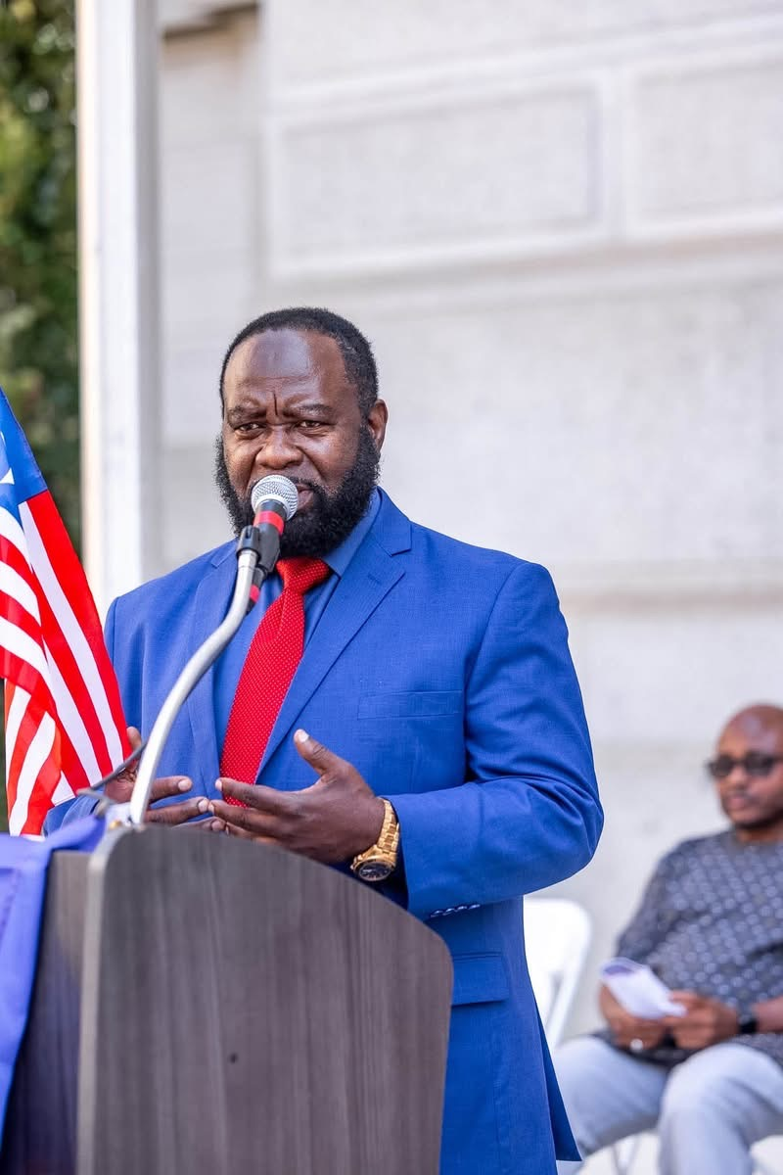
FREDRICK SAMUEL GIBSON, SR., MSc, MA, MPA, MBA
Criminologist | Criminal Justice Professional | Homeland Security Practitioner
Transnational Crime & Drug-Trafficking Research Analyst
FROM ACCUSATION TO ACCOUNTABILITY
A Generative Analysis of “The Conspiracy That Failed”
A Critical, Moral, Philosophical, and Institutional Reflection on an Article Attributed to Dr. H. Boima Fahnbulleh, Jr.
SERIES  Genesis Weekly Publications | EDITION  August 21, 2026 | FRAMEWORK  Generative Justice & Reform

EDITORIAL POSITION
This commentary examines the reasoning, moral claims, political language, evidentiary weaknesses, and institutional implications of the article. It does not authenticate its authorship or convert its disputed allegations into established facts.

Introduction: A Politically Explosive National Narrative
I have carefully reviewed the article titled “The Conspiracy That Failed: The Rise and Fall of a Criminal Drug Cartel in Liberia,” attributed to Dr. H. Boima Fahnbulleh, Jr., a prominent Liberian political thinker and former national security adviser during the administration of President Ellen Johnson Sirleaf.
The article is politically explosive, morally forceful, and rhetorically uncompromising. It presents a sweeping account of alleged drug trafficking, money laundering, diplomatic-passport abuse, election manipulation, government corruption, institutional infiltration, and criminal conspiracy during and following the administration of former President George Manneh Weah.
Because these are extraordinarily serious accusations involving identifiable individuals, political institutions, and former public officials, they must be approached with intellectual discipline. My analysis does not certify the allegations as proven facts. Instead, I examine the article’s reasoning, moral claims, philosophical foundation, political language, evidentiary weaknesses, and implications for Liberia’s democratic and national-security institutions.

The Central Argument
The article advances three principal propositions.
First, it alleges that a politically connected criminal network became deeply established during the Weah administration and used state institutions, diplomatic privileges, security agencies, government finances, and international relationships to facilitate drug trafficking and other illegal activities.
Second, it contends that although the Coalition for Democratic Change lost political power in 2023, elements of the alleged network remained embedded within government and the security services, enabling information leaks and the continuation of criminal operations.
Third, it argues that recent public allegations against officials of the current Unity Party government form part of a coordinated effort to confuse the public, frighten the administration, distract international partners, and prevent investigators from uncovering the alleged criminal architecture inherited from the previous government.
These propositions present a theory of institutional or state capture: the possibility that a criminal network does not merely bribe individual officials but penetrates appointments, procurement, intelligence, diplomatic privileges, financial systems, law enforcement, and political decision-making. That is a legitimate national-security concern. It is also a claim that requires substantial and independently verifiable evidence.

The Article’s Moral Force
The article’s greatest strength is its refusal to treat drug trafficking as an ordinary political disagreement.
Drug trafficking is not simply a matter of prohibited substances crossing borders. It is an illegal system of wealth, influence, coercion, institutional corruption, and social destruction.
A transnational drug network requires more than the person carrying a package. It may depend upon financiers, transporters, warehouse operators, airport personnel, customs facilitators, corrupt security officers, document providers, money launderers, political protectors, and legitimate businesses used to disguise illegal proceeds.
When such a network becomes connected to the machinery of government, the consequences extend far beyond criminal law. Public trust collapses. Honest officers become vulnerable. Young people lose confidence in lawful achievement. Illegal money begins influencing political competition, appointments, public contracts, and national priorities.
The article is therefore morally correct in insisting that Liberia must not tolerate political protection for anyone involved in drug trafficking, regardless of party, position, wealth, or relationship to the presidency. There should be no sacred cows under either the CDC or the Unity Party.

Where the Article Becomes Morally Problematic
Although the article condemns corruption and criminality, some of its language undermines the moral authority of its argument.
Descriptions of people as “dregs,” personal attacks on intelligence and character, references to sexual behavior, and derogatory descriptions of women and foreign nationals do not constitute evidence. They introduce humiliation, class prejudice, misogyny, and personal contempt into what should be a disciplined national-security analysis.
A person’s educational limitations, lifestyle, profession, nationality, or social background does not establish participation in organized crime. Criminal responsibility must be individual and evidence-based.
The language of moral disgust may mobilize political supporters, but it can also obstruct the search for truth. Once an analysis becomes dominated by contempt, opponents can dismiss the entire argument as partisan hostility—even when some underlying concerns may deserve investigation. Liberia needs moral courage, but moral courage must be accompanied by moral restraint.

The Evidentiary Deficit
The article makes grave allegations concerning cocaine trafficking, misuse of diplomatic passports, suspicious withdrawals from public institutions, money laundering, election manipulation, security-service infiltration, and an allegedly fabricated cartel video. Each claim is potentially investigable. The article, as presented, does not provide the documentation necessary to prove them.
If diplomatic passports were improperly issued, the public should be shown passport records, approval documents, dates, recipients, travel histories, and the legal authority under which those passports were granted.
If more than US$100 million was removed through national-security or financial institutions, investigators should examine treasury records, bank transfers, payment instructions, legislative appropriations, audit trails, and the officials who authorized and received the funds.
If concessionaires advanced two years of revenue, the agreements, correspondence, payment records, and accounting treatment should be disclosed. If ballot boxes were stuffed or election officials compromised, the allegations should be supported by polling-place records, observer reports, witness testimony, tally discrepancies, judicial findings, or other verifiable evidence.
If a cartel video was fabricated, forensic investigators should examine its metadata, original files, recording location, devices, financial sponsorship, communication records, and the identities of those who allegedly planned or distributed it. A compelling political narrative is not the same as a criminal case. The stronger the accusation, the greater the burden of proof.

The Danger of Replacing One Partisan Narrative With Another
The article appears to position the CDC as the origin and protector of the alleged cartel while portraying the Unity Party government as the institution attempting to dismantle it. That may be the author’s conclusion, but a generative analysis must ask a harder question: What if criminal networks are not confined to one political party?
Organized crime is pragmatic. It does not necessarily possess a permanent political ideology. It purchases access wherever access is available. A trafficking network that developed relationships under one administration may attempt to cultivate new protectors under the next.
Therefore, the investigation cannot begin with the assumption that every CDC official is guilty or that every Unity Party official is innocent. If the country accepts a partisan theory before examining the evidence, Liberia may simply replace one form of political protection with another.
The fight against drug trafficking must not become an extension of the 2023 election. The standard must be consistent: investigate former and current officials, political financiers, security personnel, private businesses, and foreign collaborators; follow the evidence wherever it leads; and prosecute only where credible and admissible evidence supports prosecution.

A Philosophical Conflict: Retribution or Regeneration?
The article is fundamentally retributive. It seeks exposure, defeat, punishment, and the collapse of an alleged criminal-political enterprise.
Retribution has an appropriate place in justice. People who traffic drugs, corrupt public institutions, launder criminal proceeds, or protect organized crime must face legal consequences.
But the Genesis Generative Framework asks an additional question: What must Liberia build so that another cartel cannot replace the one allegedly being dismantled?
Removing individuals without transforming systems produces only temporary relief. If the same weak border controls, compromised procurement systems, unmonitored diplomatic privileges, fragile intelligence structures, vulnerable youth populations, and politicized law-enforcement institutions remain, another network will eventually occupy the available space.
A generative response does not stop at identifying villains. It rebuilds the conditions that allowed criminality to grow.

What a Generative National Response Requires
1. Establish an independent transnational-crime commission. Include qualified representatives from law enforcement, financial intelligence, prosecution, customs, immigration, port security, civil society, and appropriate international partners.
2. Audit diplomatic and official passports. Review every passport issued during the relevant period for recipient, legal justification, approving authority, travel history, and present status.
3. Conduct forensic financial audits. Examine the NSA, EPS, FIU, Ministry of Finance, Central Bank, and relevant institutions for extraordinary withdrawals, unexplained transfers, off-budget expenditures, and suspicious transactions.
4. Follow the money behind the drugs. Identify financiers, beneficiaries, transport networks, storage facilities, communication systems, laundering channels, and political protection—not only those who physically handled contraband.
5. Protect whistleblowers and witnesses. Officials and citizens cannot provide evidence if they fear dismissal, retaliation, disappearance, or political persecution.
6. Separate investigators from political influence. Anyone who has publicly defended or condemned a central subject should be evaluated for possible recusal. An investigation must be independent in fact and appearance.
7. Strengthen treatment and prevention. Enforcement must be accompanied by treatment, rehabilitation, prevention, family support, mental-health services, education, youth employment, and community reintegration.
8. Publish an evidence-based national report. Distinguish established facts, unresolved allegations, prosecutable conduct, institutional failures, and recommended reforms.

My Professional Assessment
The article attributed to Dr. Fahnbulleh raises a potentially significant theory of criminal-political organization and institutional continuity. Its warning that an alleged cartel may have survived a change of government deserves serious consideration.
Its moral strength lies in its insistence that organized crime may operate through political, financial, diplomatic, and security structures. Its principal weakness lies in its partisan certainty, derogatory language, and failure—within the article itself—to present the documentary and forensic evidence required to establish its most serious claims.
The answer is neither to dismiss the article nor to adopt it as a national verdict. The answer is to test it.
Every allegation capable of verification should be submitted to an independent investigative process. Every financial claim should be audited. Every named individual should have the opportunity to respond. Every responsible person against whom credible evidence is established should be prosecuted. Every unsupported allegation should be corrected.

Conclusion: Liberia Needs Truth That Can Survive the Courtroom
Liberia cannot build a just republic through accusation alone. Neither can it preserve democracy by silencing uncomfortable allegations.
The country requires truth that can survive political change, media scrutiny, forensic examination, and judicial review.
A cartel cannot be dismantled merely by changing governments. It is dismantled by following the money, protecting witnesses, securing borders, professionalizing law enforcement, reforming institutions, prosecuting the guilty, treating those affected by addiction, and eliminating the conditions through which criminal networks purchase influence.
The objective must not be to prove that one political party is entirely evil and another entirely innocent. The objective must be to establish a Liberian state in which no political party, public official, security officer, businessperson, foreign trafficker, or criminal financier is powerful enough to stand above the law.
THE GENERATIVE PRINCIPLE
That is the difference between partisan accusation and generative justice. One seeks to defeat an opponent. The other seeks to build a republic.

About Genesis Global Initiatives
This commentary forms part of the Genesis Global Initiatives Weekly Publications Series and is prepared under the Genesis Generative Framework for independent research, policy analysis, and public education. Genesis Global Initiatives, Inc. is a nonpolitical and nonpartisan organization committed to public safety, youth empowerment, drug prevention and treatment, rehabilitation, institutional accountability, inclusive development, and national renewal.
This publication is intended for placement on and public access through the Genesis Global Initiatives website as part of its Weekly Policy & Public Safety Review.

About the Author
FREDRICK SAMUEL GIBSON, SR., MSc, MA, MPA, MBA
President and CEO, Genesis Global Initiatives, Inc.
Fredrick Samuel Gibson, Sr. is a criminologist, criminal justice professional, homeland security practitioner, public-policy analyst, rehabilitation and recovery specialist, and researcher of organized crime and transnational drug-trafficking systems. His work examines public safety, institutional reform, ethical governance, community recovery, and national renewal.

Editorial and Legal Notice
IMPORTANT DISCLAIMER
This commentary analyzes an article attributed to Dr. H. Boima Fahnbulleh, Jr. It does not independently certify the article’s authorship or declare any person, administration, or political organization guilty of criminal, civil, or ethical misconduct. All disputed accusations remain allegations unless established through authenticated evidence, an independent investigation, and appropriate judicial proceedings. Nothing in this publication constitutes legal advice or interference with an active investigation.

© 2026 Genesis Global Initiatives, Inc. | Weekly Publications Series

